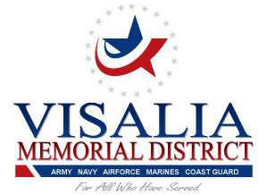
Board of Directors Meeting
Wednesday May 25, 2022
609 W Center Ave.
Visalia, Ca. 93291
1800 hrs.
AGENDA #5-22
- CALL TO ORDER
- ROLL CALL
- PUBLIC COMMENTS
NOTICE TO THE PUBLIC COMMENT PERIOD At this time, members of the public may comment on any item not appearing on the agenda. Under state law, matters presented under this item cannot be discussed or acted upon by the Board at this time. For items appearing on the agenda, the public is invited to make comments at the time the item comes up for Board consideration. Any person addressing the Board will be limited to a maximum of three (3) minutes so that all interested parties have an opportunity to speak. At all times, please use the microphone and state your name and address for the record.

- ACTION ITEMS

- District Financial Expense & Revenues update
- Election update
- Pub Lease review
- Outside checking account
- Sexual and Ethical training.

- It is the intention of the Board of Directors to meet in closed session pursuant to Government Code section 54956.9(d)(2) with respect to anticipated litigation: SIGNIFICANT EXPOSURE TO LITIGATION – ONE CASE.
- Report of actions taken in closed sessions, if any.
- Adjournment

NOTICE TO THE PUBLIC**NOTE: agenda items are available for public viewing during regular business hours, monday-friday, 10am to 4pm at the Visalia veterans memorial building, 609 w. center, 93291
CLOSED SESSIONS
As provided in the Ralph M. Brown Act, Government Code sections 54950 et seq., the Board of Directors may meet in closed session with members of its staff, and its attorneys. These sessions are not open to the public and may not be attended by members of the public. The matters the Board will meet on in closed session are identified below or are those matters appropriately identified in open session as requiring immediate attention and arising after the posting of the agenda. Any public reports of action taken in the closed session will be made in accordance with Government Code sections 54957.

